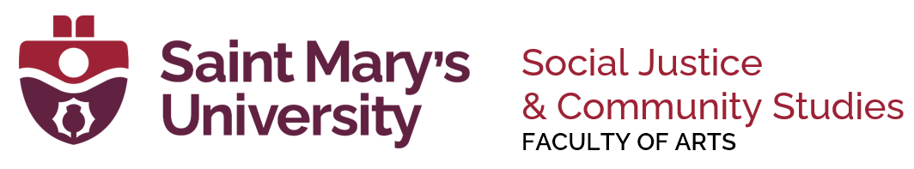
Social Justice & Community Studies Student Assistant Job Description
Position Title: Teaching Assistant

Duties:
- Primary duty is to assist in the delivery of SJCS curriculum (not all duties below will apply in every course TAship)
- Course Preparation, Delivery, IT, and other faculty & student assistance
- Understanding course curriculum & goals, incl. strong grasp of syllabus, course materials
- Proctoring exams
- Grading course assignments under the guidance of the instructor
- Deeper Understanding of course readings/material where relevant to grading
Expectations:
- Skilled and knowledgeable in the subject area(s), and in SJCS
- Brightspace & Zoom Training with Studio & SJCS TA Training before course starts
- Able to work independently, confidentially, and with care for details
- Punctual, motivated, and reliable
- Able to ask for assistance and additional instructions when needed
- Report any possible issues of academic dishonesty (including possible unauthorized and/or uncited use of generative AI in course work) or any other serious student issues to the instructor
- Handle student grades, answer keys, and any other confidential material in an appropriate manner.
Requirements:
- 4th year undergraduate, recent SJCS graduate (less than 1 year out), or graduate students
Hours:
- 30 hours (undergraduate, @ $22/hour) per course per semester
- Distribution of hours to be done in consultation with the instructor, and agreed to by TA and instructor
- Invigilation duty or other department duty may contribute towards the total hours.

Application Checklist:
- Copy of unofficial SMU transcript
- Completed and signed copy of application form
- Copy of resume (all documents should be merged into one PDF)

Teaching Assistant Application

Name: |  | Primary Email Address:
A#: | S#: |  | Gender Pronouns (if desired)

As a currently registered student, what is your program & main department(s)?

Undergraduate Undergraduate Honours Recent Graduate
Date of Graduation_________

Department(s):

What year are you in as of this September (e.g. YEAR 4):

Term(s) Applied for Fall Winter Both

Timeslots you are NOT available for the term(s) you want to TA

Academic and paid work experience relevant to Teaching Assistantship for SJCS (be sure to list relevant courses taken as student or TA’d, relevant community or paid work, lived experience).

Submit this application by email with a copy of your unofficial transcript and your resume as a single PDF. Email your complete application to: sjcs@smu.ca by Friday, August 22, 2025

---------------------------------------------------------- ----------------------------------------
STUDENT SIGNATURE DATE

